Sishir Yeety

Tutorial 1

July 20, 2020

**1)**

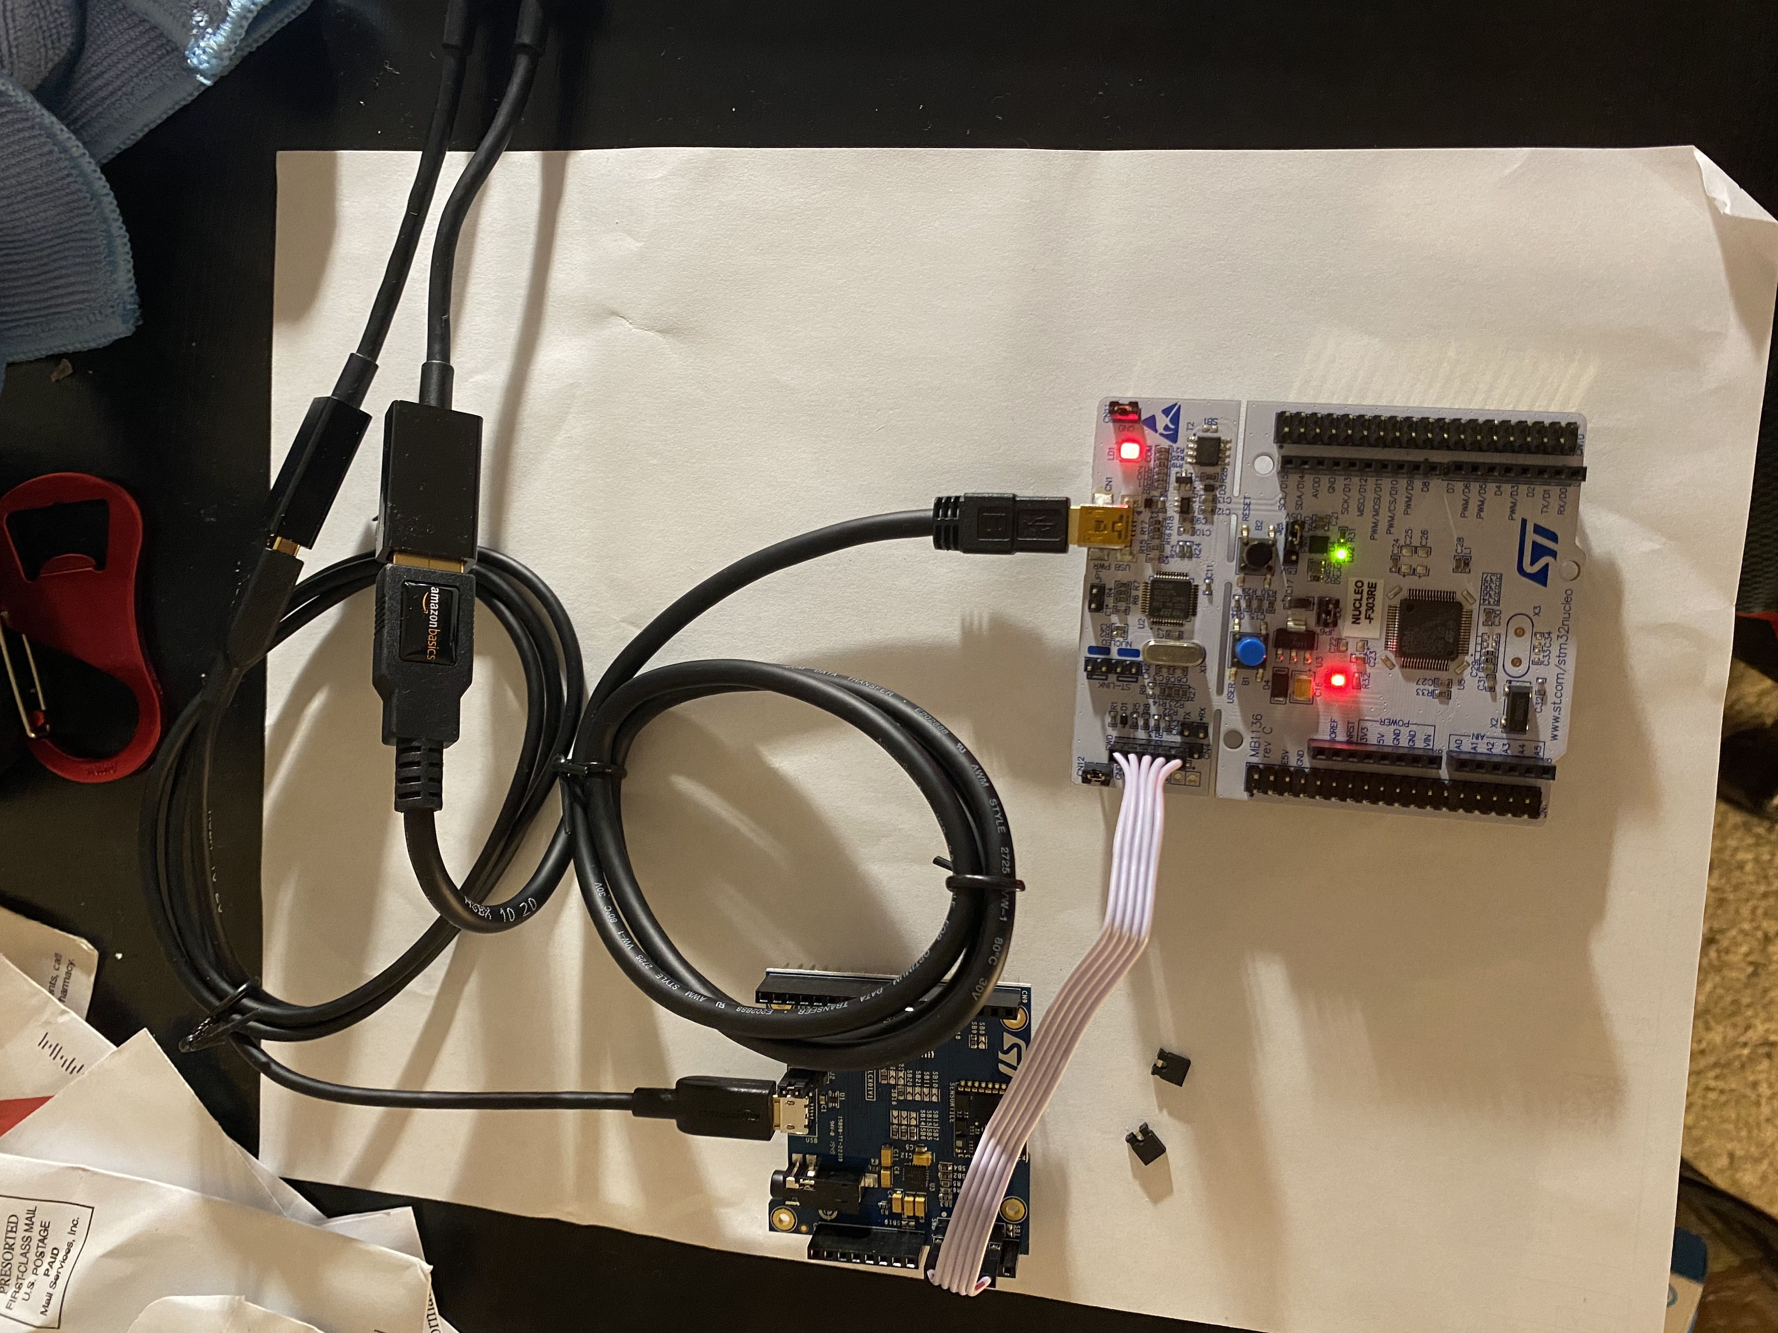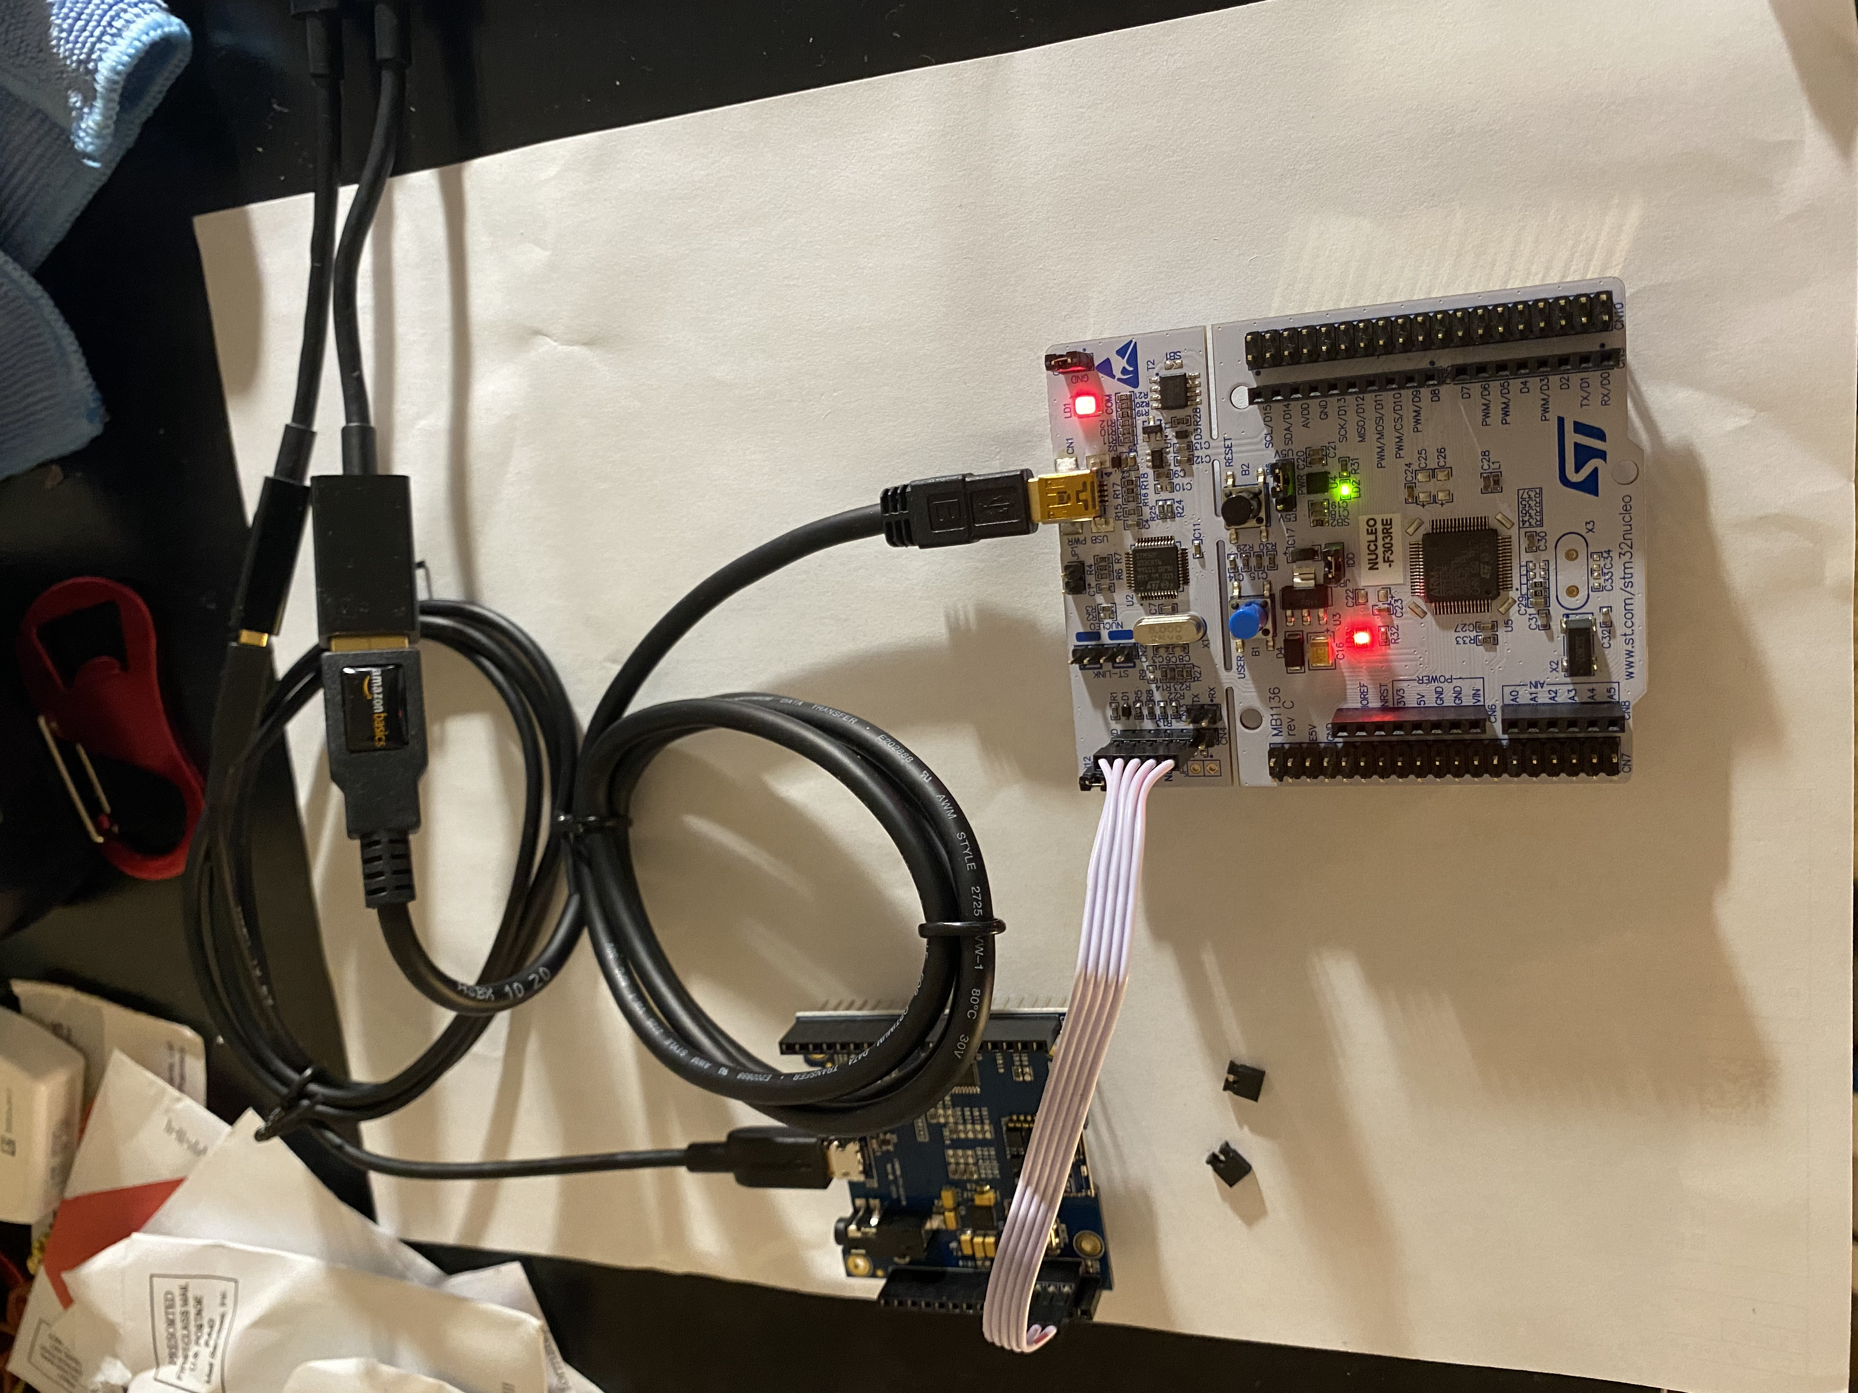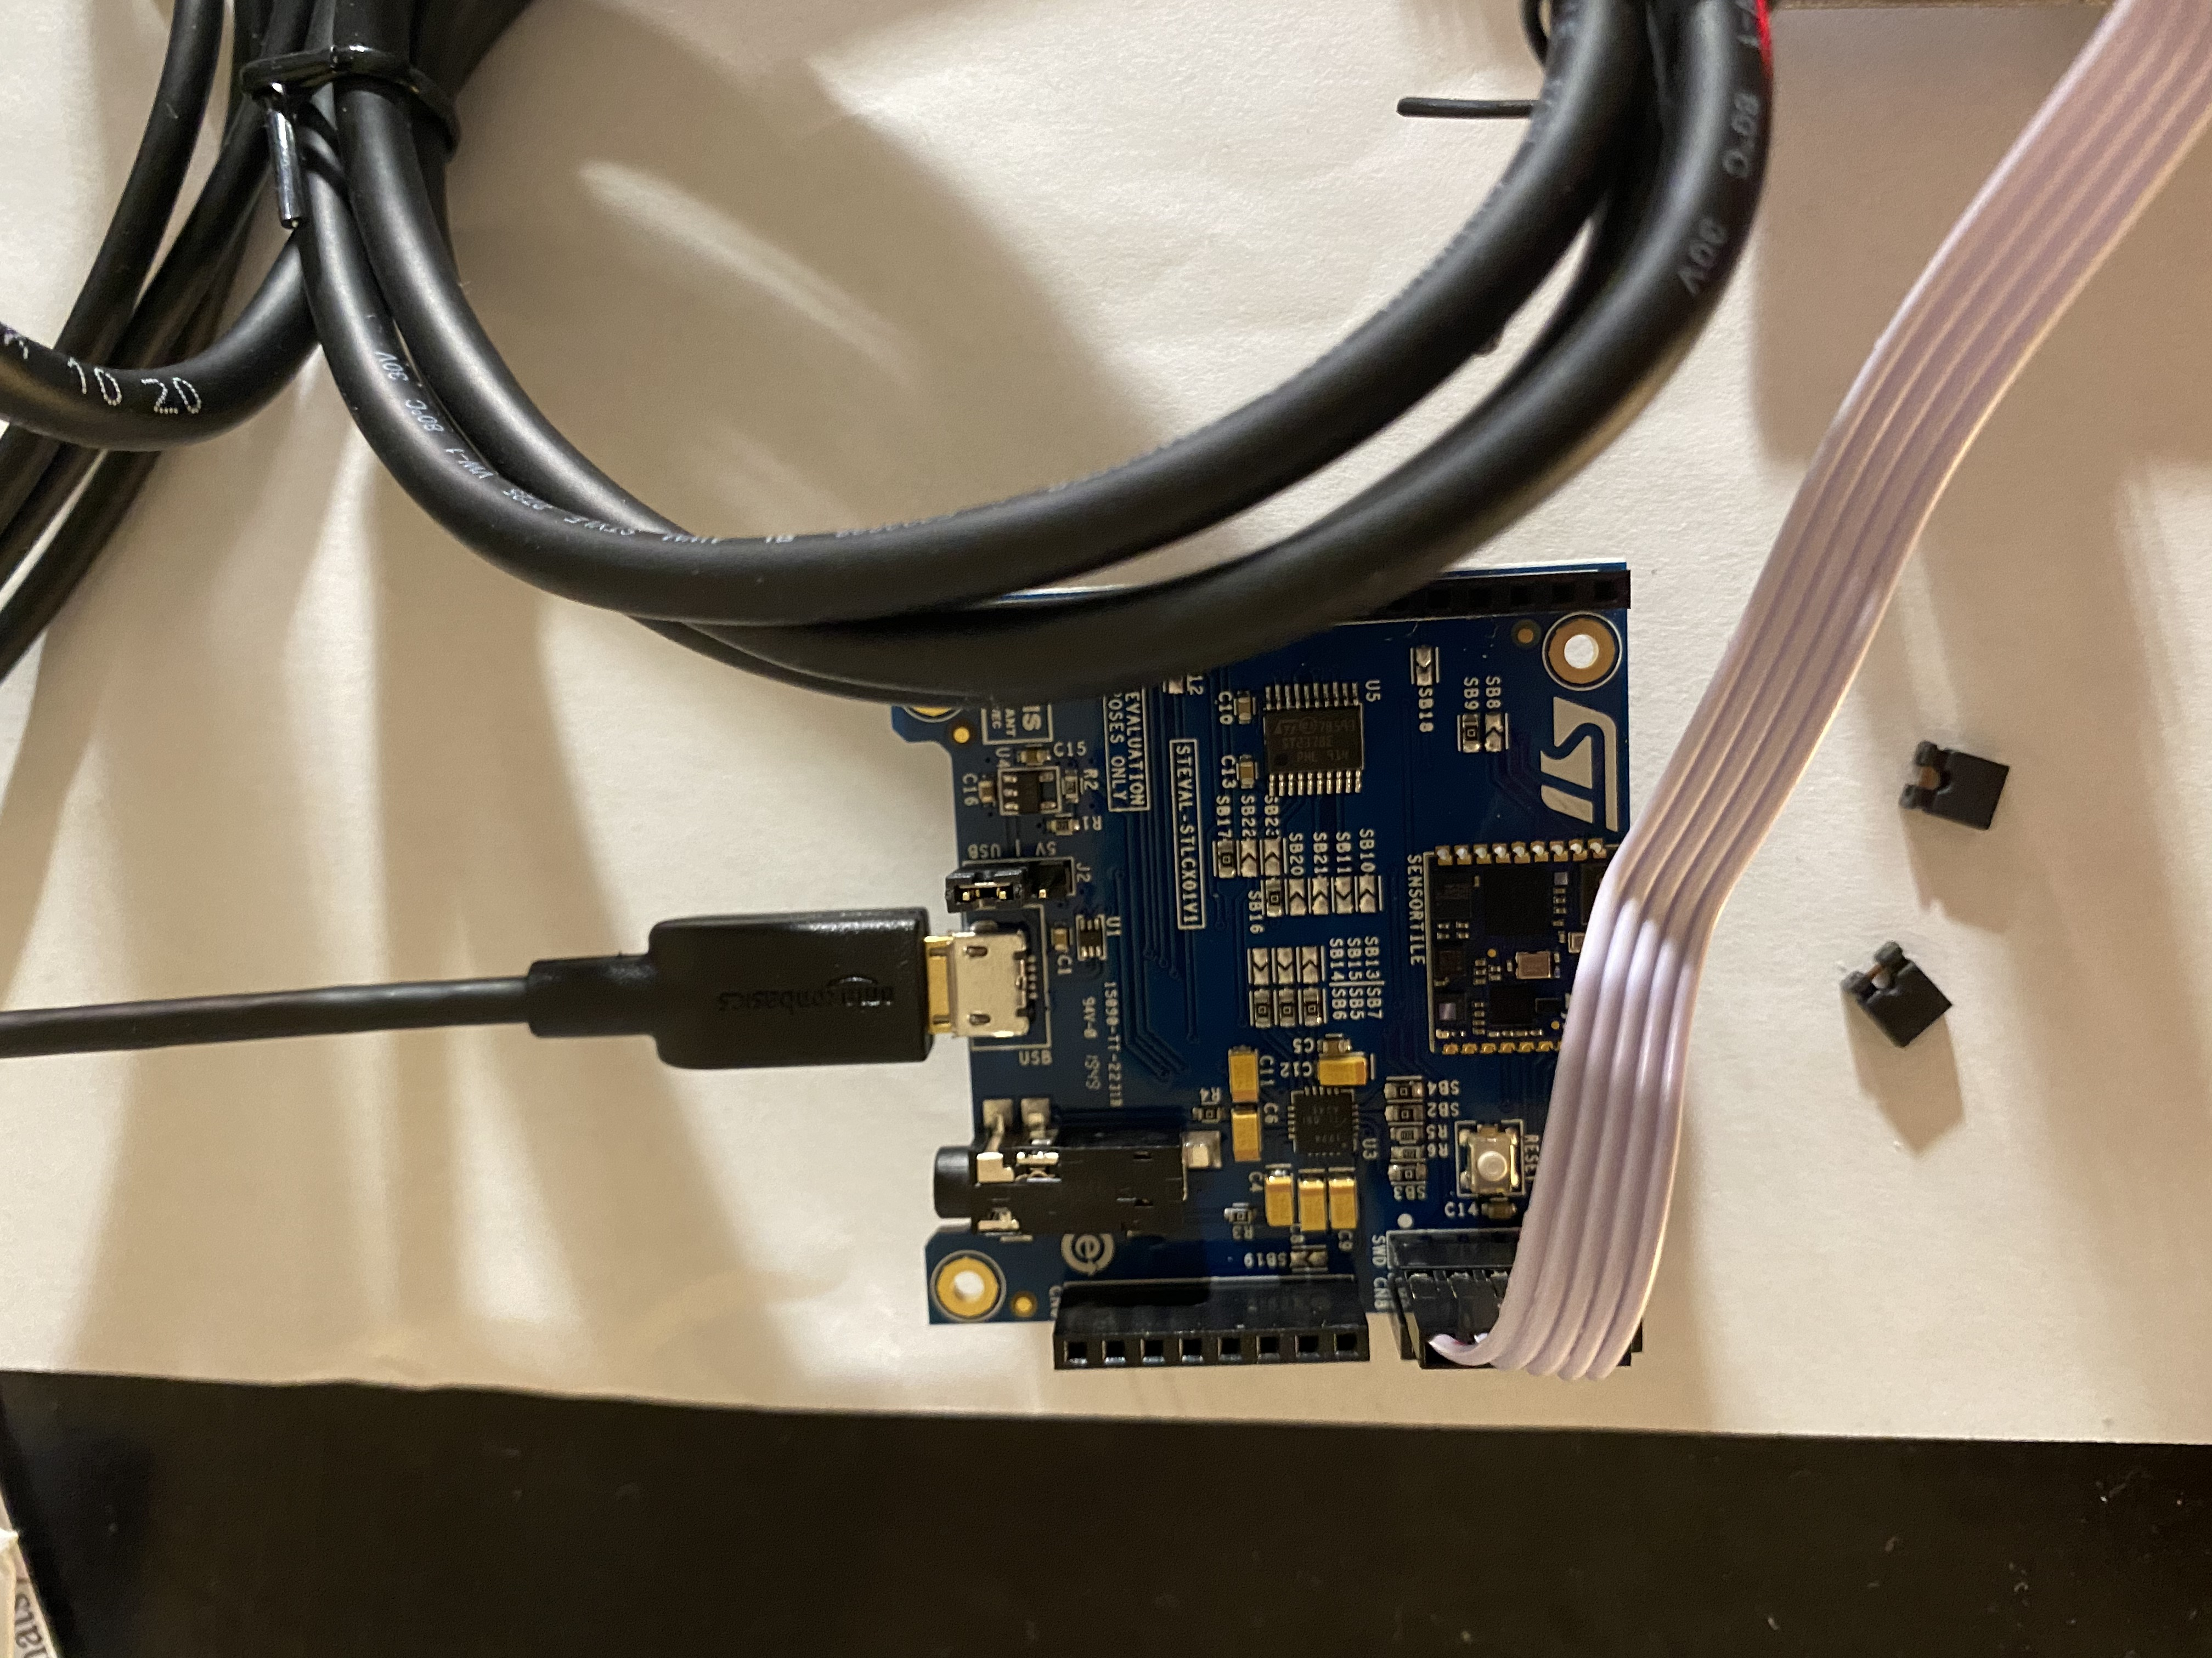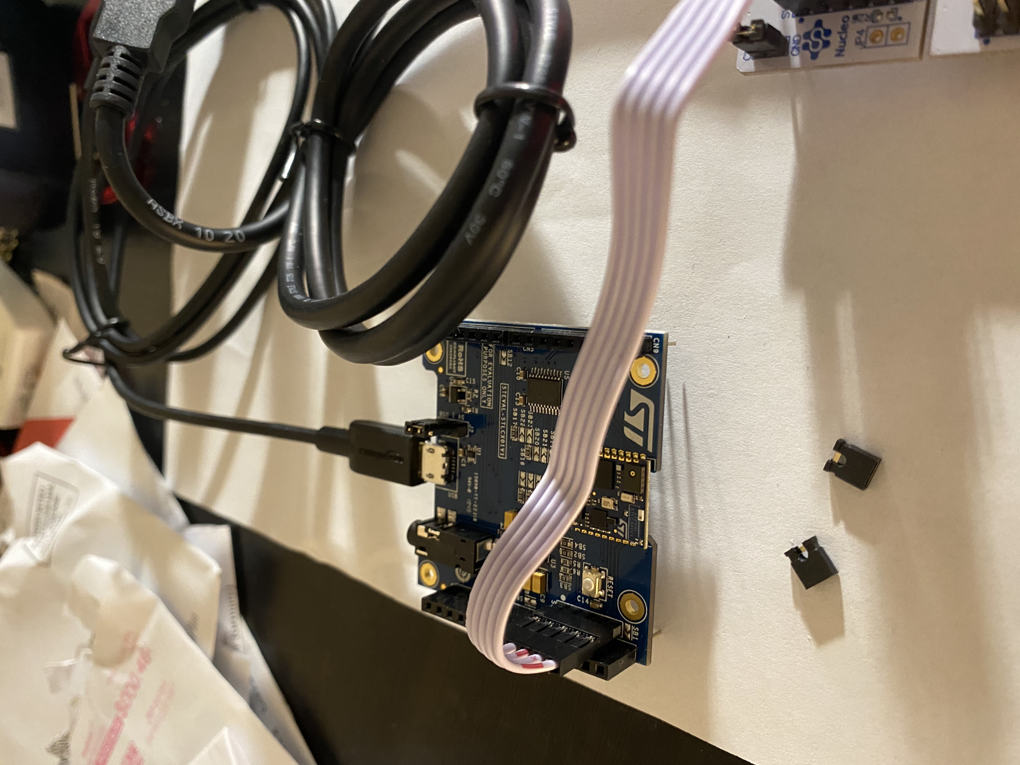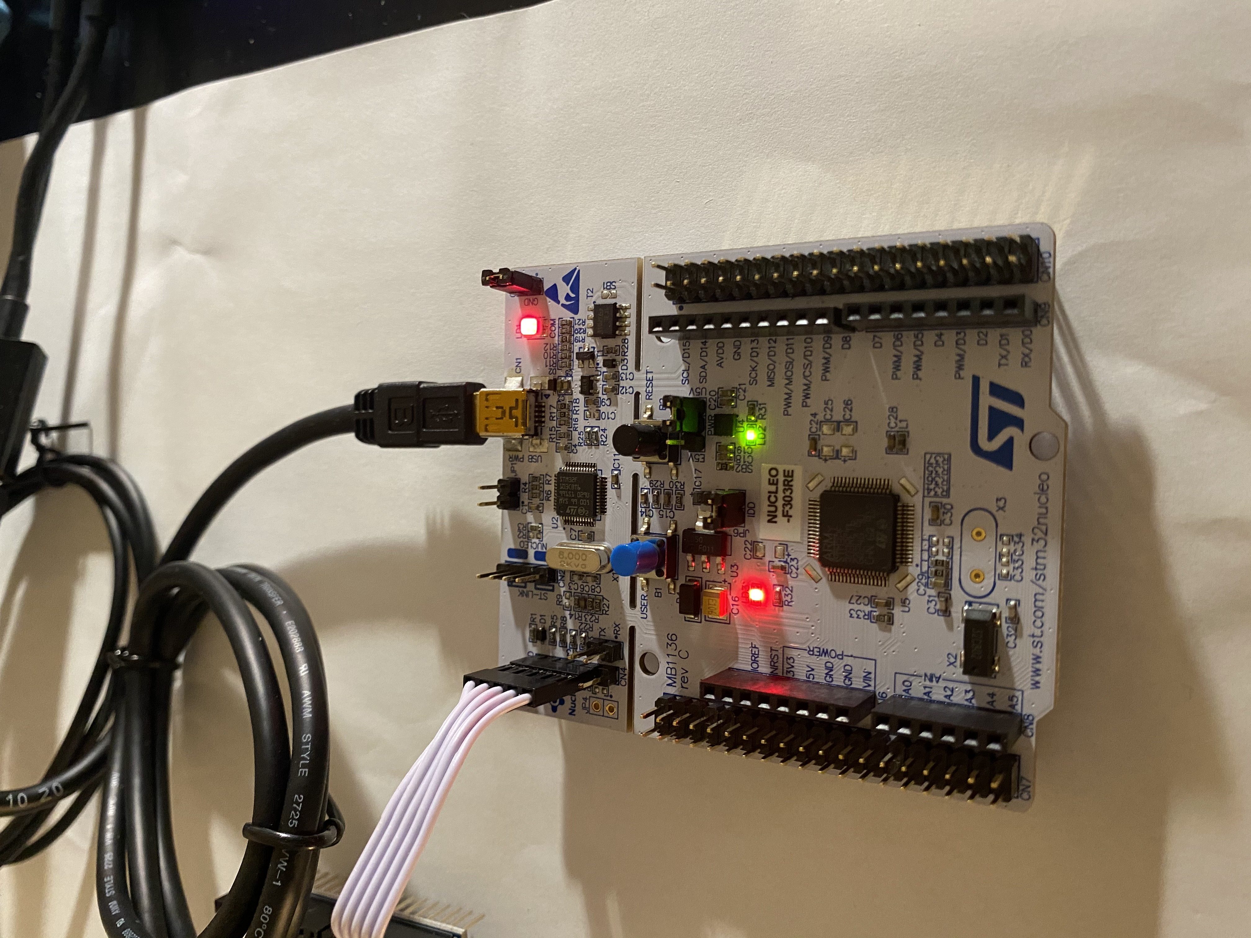

**2)**

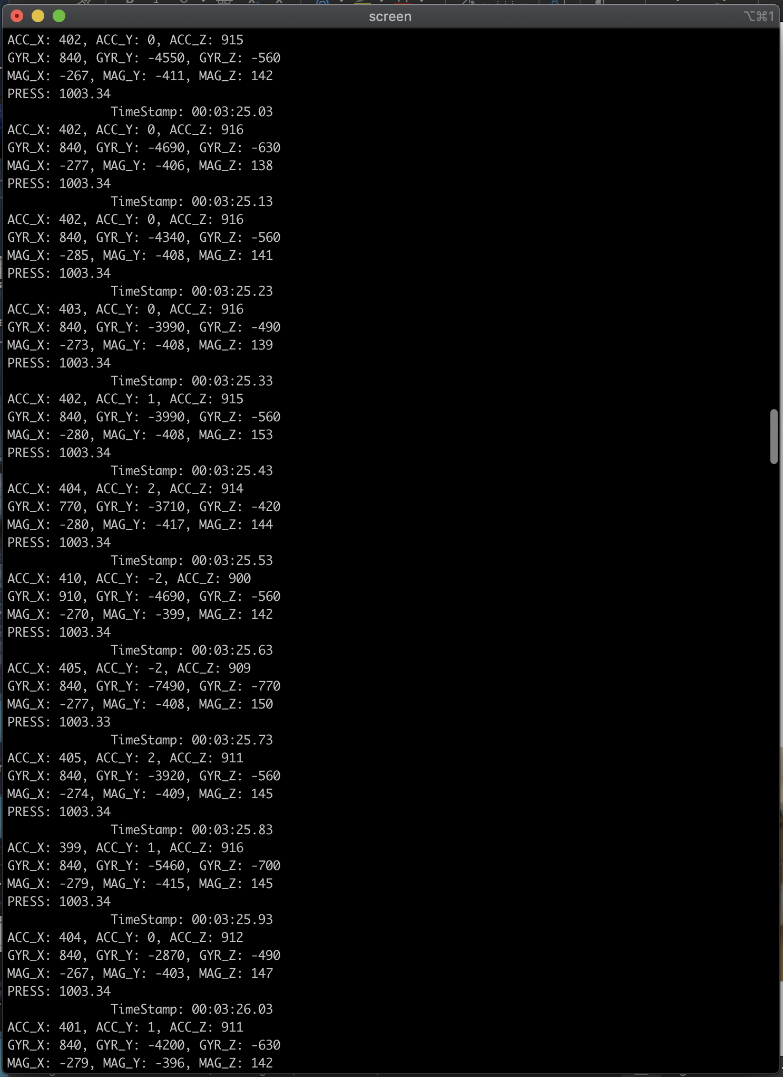

**3)**

The SWD connector on the SensorTile allows us to send/receive data from the SensorTile (and program it) before the compiled binary file has been loaded onto it for execution

**4)**

The Nucleo board allows us to debug and program the sensors

**5)**

What it means to flash the sensor is that we are uploading the compiled binary file onto the SensorTile for execution, so that it doesn’t have to go through the Nucleoboard and SWD cable. The program has been put onto the SensorTile’s chipset and can run independently of the nucleoboard or needing an IDE.

**6)**

The role of the SensorTile itself is that it contains all the different chips/sensors that give us data in the Terminal window. Now the SensorTile board, it serves a really important role. It interfaces with external devices through the SWD connector (such as the Nucleo board) and the USB port. It also contains an audio DAC chip and other chips. For example, without the board, we would not have been able to program the Sensortile with the compiled binary files.

**7)**

It can run independently of the SWD cable and NucleoBoard because the IDE helped the NucleoBoard upload the compiled binary file onto the SensorTile for execution. So now when the SensorTile is plugged into the computer, it runs that compiled code instead of having the IDE and NucleoBoard run it.

**8)**

The most challenging part in terms of hardware was forgetting to put the sensor on the sensor cradle. I didn’t realize it was missing and the tutorial didn’t make it clear, until someone on Piazza was talking about it.

**9)**

The most challenging part was to have to uninstall the newest version of the st link software and get an older one, due to some incompatibility with the newest OS X.

**10)**

It was very easy to follow. I did not have any major issues to report